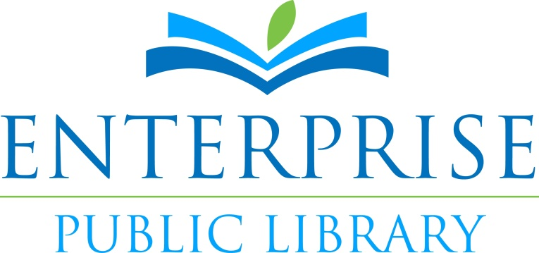

**Materials Selection Policy**

The mission of the Enterprise Public Library is to provide open access to information and to promote literacy, love of reading, and lifelong learning opportunities for all members of the community.

1. PRINCIPLES  
   The Enterprise Public Library Materials Selection Policy is based on the following principles:
   1. Materials are selected which provide for the interest, information, enlightenment, entertainment, education, development, enrichment, and/or self-improvement of all library patrons, within budgetary constraints and availability of materials.
   2. The freedom to read, along with the freedom to hear and to view, is protected by the [First Amendment to the Constitution of the United States](http://www.ala.org/ala/aboutala/offices/oif/firstamendment/firstamendment.cfm). This freedom, essential to our democracy, will be upheld, supported, and defended in the selection and accessibility of all library materials. In this regard, the library upholds the principles of the American Library Association's [Library Bill of Rights](http://www.ala.org/ala/issuesadvocacy/intfreedom/librarybill/index.cfm), [Freedom to Read](http://www.ala.org/ala/aboutala/offices/oif/statementspols/ftrstatement/freedomreadstatement.cfm), [Freedom to View](http://www.ala.org/ala/mgrps/rts/vrt/professionalresources/vrtresources/freedomtoview.cfm), [Statement on Labeling](http://www.ala.org/ala/issuesadvocacy/intfreedom/librarybill/interpretations/labelingrating.cfm), and [Free Access to Libraries for Minors](http://www.ala.org/ala/issuesadvocacy/intfreedom/librarybill/interpretations/freeaccesslibraries.cfm) as well as to the Texas Library Association's [Intellectual Freedom Statement](http://www.tsl.state.tx.us/ld/pubs/plant/intellfreedom.html).
   3. Selection of materials does not constitute or imply agreement with or approval of the content, viewpoint, implications, or presentation of the materials.
   4. The library staff does not serve *in loco parentis*. It is the parent(s), and only the parent(s), who may restrict their children, and only their own children, from access to library materials. Responsibility for children's reading rests with their parent(s) and/or legal guardian(s). Selection will not be inhibited by the possibility that materials may inadvertently come into the possession of children.
   5. The library is not a judicial body. Laws governing obscenity, subversive materials, and other questionable matters are subject to interpretation by the courts. Consequently, no challenged material will be removed from the library for complaints of obscenity, pornography, subversiveness, or any other category covered by law until after receipt of an independent court order. Conversely, materials previously judged unlawful will not knowingly be selected.
2. POLICY  
   In accordance with the above principles, the following policies apply in regard to materials selection and accessibility for the general library collection.
   1. Selection  
      As budgetary constraints limit the purchase of materials, the selections made follow the aforementioned principles while attempting to maintain diversity, quality and responsiveness to patron interest patterns. As such, selections are made on the basis of any one, several, or all of the following considerations:
      1. Diversity is pursued by attempting to meet the needs of all ages, backgrounds, and educational levels, by providing as many subject fields as possible, and by providing alternative perspectives on unpopular or unorthodox as well as popular materials. The collection represents various opinions and viewpoints on all issues of general concern and should broadly reflect the various ethnic and social groups in the City.
      2. Quality is pursued by applying professional discretion and standards established by the library profession and through the use of appropriate selection aids, including book reviews, best seller lists, etc.
      3. The Library staff responds to community interests by careful consideration of the following: patron requests for purchases, use patterns for existing materials, purchase trends of similar materials from retailers, and any other source of information indicating community interests. The Library collection serves, to the degree possible, the interests of a diverse community without exclusion. Responsiveness to the interest of one individual or group is not restricted on the basis of dislike or objection of another individual or group.
      4. Undue duplication of materials is avoided, either in the library itself, or with other institutions in the community. Esoteric or very technical works, and materials available elsewhere to special interest groups, are generally excluded from the collection. Materials may also be excluded if the existing collection already covers the field.
      5. Materials with formats that do not conform or lend themselves to library use are usually excluded.
      6. Gifts, unsolicited materials, and citizen suggestions for purchases are all evaluated under the same policies, principles, and selection criteria as regularly purchased materials.
   2. Criteria  
      Materials selections are made on the basis of any one, several, or all of the following specific criteria:
      1. A positive review in at least one of the following review journals:
         * *Library Journal*
         * *Publisher's Weekly*
         * *Kirkus Reviews*
         * *Booklist*
         * *School Library Journal*
         * *Horn Book*
         * *Bulletin of the Center for Children's Books*
         * *Science Books & Films*
         * *New York Times Book Review*
      2. High standards of quality in content, expression and physical attributes (binding, printing, paper quality).
      3. Contents that are timely, accurate, and representative of various viewpoints.
      4. Significant reputation of the author, editor, producer or illustrator
      5. Established reputation of publisher in the mainstream of the industry. Demonstrated acceptance of small presses by listings in standard selection sources
      6. A strong likelihood that material will not be available in other libraries of the community.
      7. Contemporary significance, potential usefulness, appeal or cultural value of the title.
      8. Reasonable cost with regard to budget restrictions.
      9. Using the *New York Times Book Review Best Seller* list as a reputed indicator of potential demand, a minimum of one copy of each title on the list will generally be purchased.

Formats collected include books, periodicals, newspapers, maps, audio and video recordings, graphic novels, and online databases. New and/or emerging formats will be considered when appropriate. The collection does not include pop-up books, coloring books, workbooks, cutout books, or fragile, multipart items that will not withstand circulation. Other criteria to be considered for formats other than books include:

* + 1. Periodicals and newspapers are selected to include current information not available in book format. Back issues are retained in paper, microform or computerized formats considering reference usefulness, customer interest, and space limitations.
    2. Audio recordings will include music on compact disc and audiocassette, and books on tape. Video recordings will include educational materials, children's, and feature films. Selection considerations for audio and video include reviews, appearance on standard charts (such as Billboard) and award lists (such as Grammys), customer requests, and high production and performance quality.

**Revised 3/2016**